1. Data source
UrbanSound8k / ESC-50
Mapping Rule: All original classes are unified into project-specific target classes defined in data/meta/class_map.csv, also with “is_hazard” “risk_weight”
2. Pipeline overview
Raw Audio→ 00_build_meta → 01_preprocess_audio → 01b_apply_class_map → 02_slice_label → 03_extract_features → Features & Visualizations
Stage | Script | Function | Key Output
0. Setup | download_urbansound8k.py | Pulls raw data. | data/raw/urbansound8k/...
1. Meta | 00_build_meta.py | Scans audio and creates initial metadata. | data/meta/data_dict.csv
2. Clean | 01_preprocess_audio.py | High-pass filtering, resampling, RMS normalization. | data/meta/data_dict_processed.csv
3. Label | 01b_apply_class_map.py | Applies custom class map and risk weights. | data/meta/data_dict_processed_labeled.csv
4. Segment | 02_slice_label.py | Slide-window segmentation (slicing) and label propagation. | data/meta/slices.csv (Training Entry)
5. Feature | 03_extract_features.py | Extracts 2D log-Mel and 1D aggregated features. | data/meta/features_index.csv (Model Entry)

3. Details of the scripts
1. 00_build_meta.py
Aspect | Description
Function | Recursively scans the raw data directory (data/raw/), identifies all audio files (WAV/MP3), and extracts initial metadata (source dataset, original class name, fold information) based on dataset-specific CSVs.
Key Logic | Uses helper functions (load_urbansound_meta, load_esc50_meta) to map filename to metadata. Assigns a split_hint (original fold ID) to help with non-leaky data splitting later.
Input | data/raw/ (Raw audio directories)
Output | 1. data/meta/data_dict.csv (One row per original audio file: path, source, original class, split hint).  2. data/meta/class_map.csv (A template for manual mapping: air_conditioner -> other). Needs manual editing after first run.
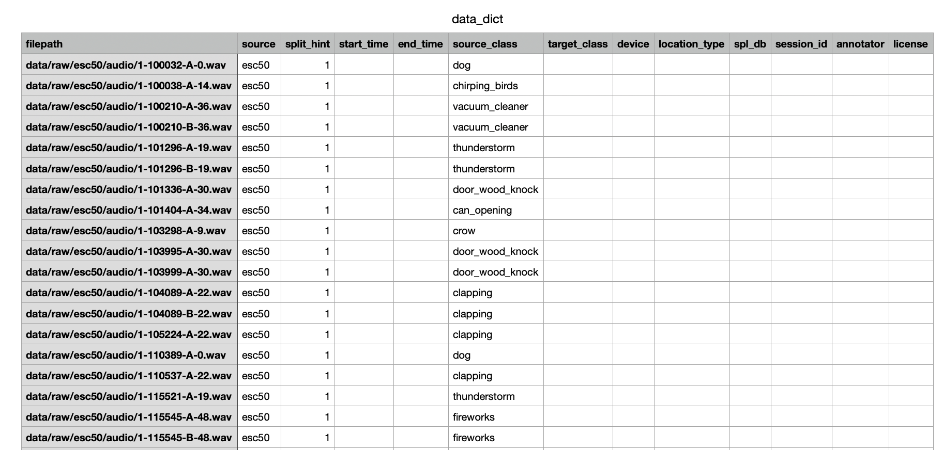
Figure 1：part of data_dict.csv
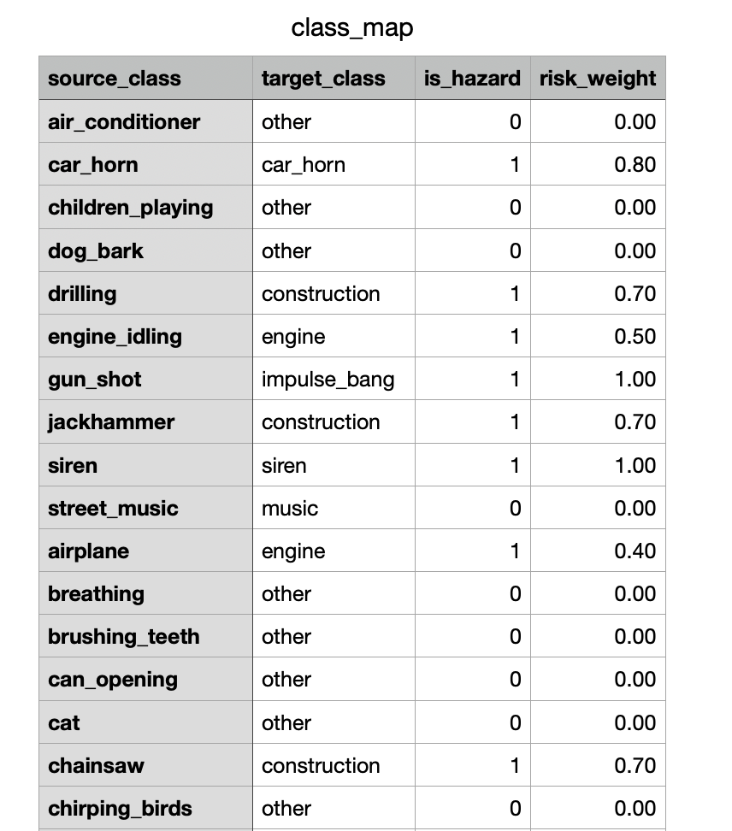
Figure 2:part of the class_map.csv
2. 01_preprocess_audio.py
Aspect | Description
Function | Performs necessary audio standardization to prepare for feature extraction.
Key Logic | 1. High-Pass Filter (HPF): Applies a 4th-order Butterworth high-pass filter at 100 Hz (apply_hpf) to remove low-frequency noise.  2. Resample: Resamples to 16kHz mono (SR=16000).  3. Normalization: Applies RMS normalization to a target RMS of 0.1 (rms_norm) for consistent loudness.  4. Quality Check: Calculates the clipping ratio (samples exceeding 0.999 amplitude) and marks the audio as 'clipped' if the ratio is >1%.
Input | data/meta/data_dict.csv
Output | 1. data/processed/orig_*.wav (HPF + Resampled version).  2. data/processed/norm_*.wav (HPF + Resampled + RMS-Normalized version).  3. data/meta/data_dict_processed.csv (Updated list with processed file paths and quality flag).
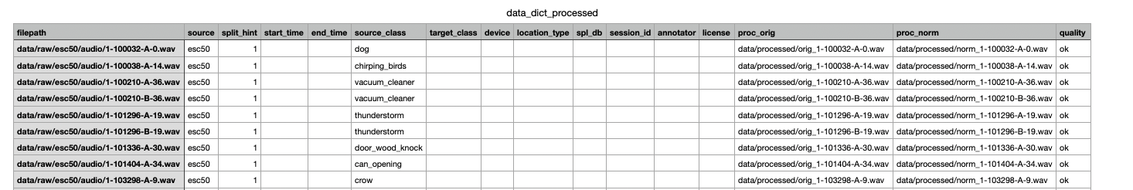
Figure 3: part of data_dict_processed.csv
3. 01b_apply_class_map.py
Aspect | Description
Function | Merges the manually edited class_map.csv into the processed metadata to assign the project-specific target class and risk attributes.
Key Logic | Performs a left-merge on the source_class column. The final target_class is prioritized from the map. It also carries over is_hazard (binary) and risk_weight (float) columns if they exist in the map, enabling risk-aware modeling.
Input | 1. data/meta/data_dict_processed.csv  2. data/meta/class_map.csv (Requires manual input)
Output | data/meta/data_dict_processed_labeled.csv (The authoritative list with the final target_class).
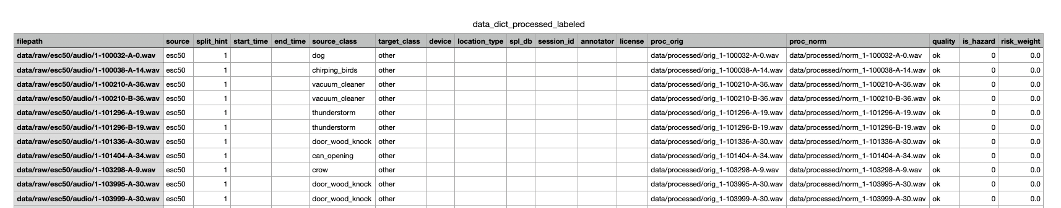
Figure 4: part of dict_processed_labeled.csv
4. 02_slice_label.py
Aspect | Description
Function | Splits long processed audio files into short, fixed-length segments (slices), which are the actual inputs for training.
Key Logic | Slide-Window: Default configuration uses a 1.0 second window and 0.5 second hop, resulting in 50% overlap. Padding: For the last segment, if the tail is shorter than 1.0s but longer than the minimum duration 0.3s, it is zero-padded to maintain uniform 1.0s length. The target_class from the parent audio is directly assigned to the slice.
Input | data/meta/data_dict_processed_labeled.csv (Uses the proc_norm audio path).
Output | 1. data/processed/slices/*.wav (Optional, saved slice audio files).  2. data/meta/slices.csv (The core index table for all subsequent feature extraction and training tasks).
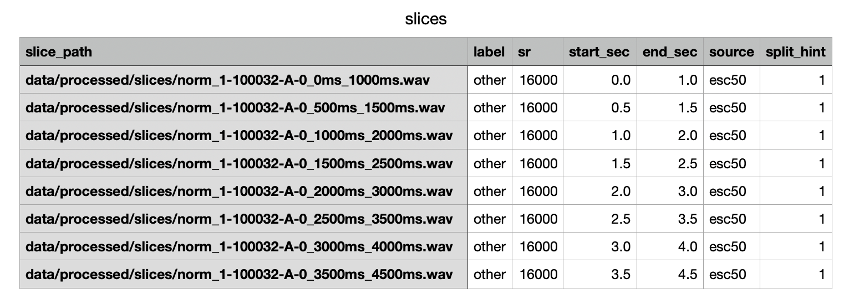
Figure 5: part of slice.csv
5. 03_extract_features.py
Aspect | Description
Function | Calculates the Mel Spectrogram (2D) and a derived aggregated vector (1D) for every slice listed in slices.csv.
Key Logic | 1. 2D log-Mel: Calculated with 64Mel bands, 25ms window, 10ms hop. Frequency range is 50Hz to 8000Hz. Normalization: Padded/trimmed along the time axis to a fixed 100 frames for CNN input uniformity.  2. 1D Aggregation: Computes the mean and standard deviation of each of the 64Mel bands across the time axis, plus the overall RMS.  3. Standardization: Calculates the global mean and standard deviation for the entire set of 1D features for future Z-score normalization.
Input | data/meta/slices.csv (Reads slice audio files).
Output | 1. data/features/logmel_2d/*.npy (2D Spectrograms).  2. data/features/agg_1d/*.npy (1D Aggregated Vectors).  3. data/meta/features_index.csv (Index linking slice to feature file paths).  4. data/meta/label_map.json (Label to Index mapping).  5. data/features/agg_stats.npz (Global mean/std for 1D feature standardization).
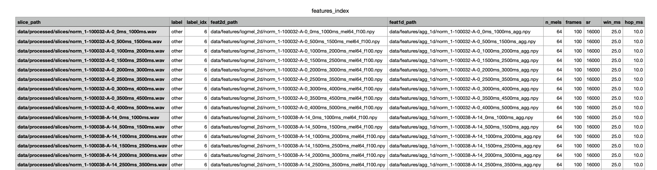
Figure 6: features_index.csv
6. make_figs_matlab.m
Figure | Function | Content | Generation
Fig 1: Label Counts | Measures data imbalance. | Displays the total number of 1s slices in each target class. Used to assess data distribution. | Reads features_index.csv and counts the label column.
Fig 2: Log-Mel Examples | Visualizes frequency-time features across different sound categories. | Shows the log-Mel spectrogram 64* 100 for a representative slice of each class. | Samples slices from slices.csv, loads WAV files, and computes the log-Mel spectrogram for plotting.
Fig 3: Mean Mel Profiles | Analyzes the average frequency energy distribution of different classes. | Plots the mean energy curve mu across the 64 Mel bands. Higher separation suggests easier classification in the frequency domain. | Samples slices from slices.csv, computes log-Mel spectra, and performs statistical aggregation (mean/std) across the time axis for each Mel band.
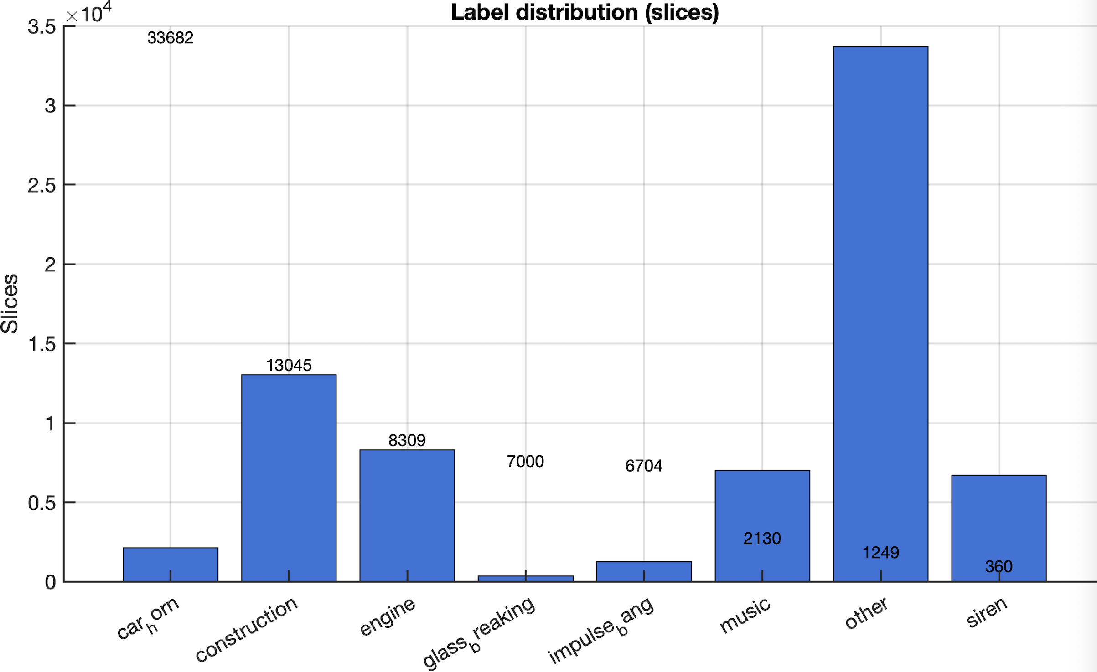
Figure 7: fig1
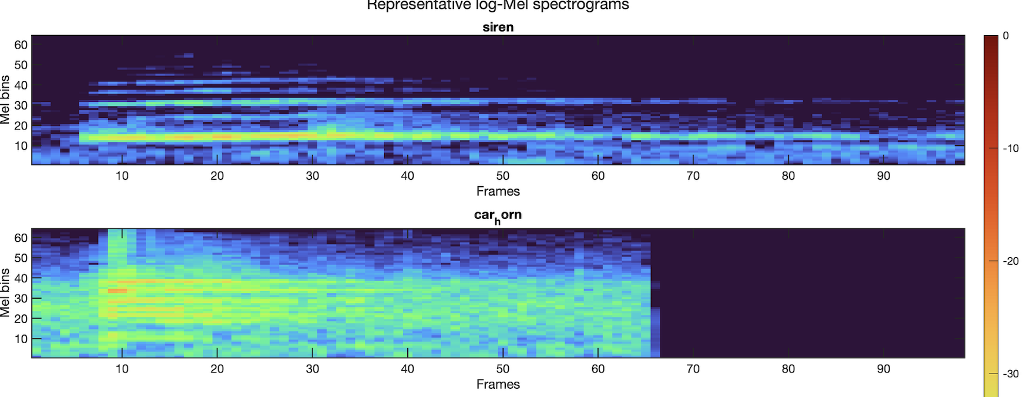
Figure 8: part of fig2
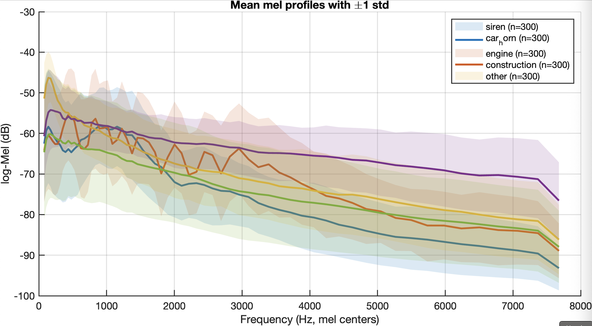
Figure 9: fig3
4. next steps
Area | Task | Details
Split Data Safely | Divide data into Train/Validation/Test sets. | Use the original recording ID (split_hint) to make sure that pieces from the same recording don't end up in different sets
Run Simple Baseline (A) | Use the 1D features for quick tests. | Train a quick model (Logistic Regression or SVM) using the 129-number feature vector. Use class weights to handle imbalanced data.
Run Deep Baseline (B) | Use the 2D features for high accuracy. | Train a small CNN using the 64* 100 spectrogram images. Use techniques like early stopping and simple data augmentation.
Check Results Thoroughly | Measure model performance using the right metrics. | Report F1 score, ROC/PR curves, and Confusion Matrix. Focus on finding which classes the model confuses the most.
Implement Risk Filter | Build the final alert system logic. | Create a post-processing filter that requires a sound to be detected N times in a row before raising an alert, and only cancels the alert after M consecutive non-detections. Combine this with the risk_weight to output a hazard tier.

